DBS MINI-PROJECT SYNOPSIS
Members:
Aakarsh jha-230905248
Arnav Sharma-230905486
Airline Management System
Problem Statement: Develop a database-driven Airline Management System to handle various airline operations efficiently. The system will manage flights, bookings, ticketing, passengers, and flight schedules, ensuring smooth operations and a better customer experience.

Abstract: The Airline Management System will make airline operations easier by managing flights, bookings, and passenger details in one place. Admins can handle schedules, airports, and pricing, while passengers can book tickets. The system will also track flight delays and manage loyalty programs to improve customer experience and streamline processes.

DDL Commands
Airline Table
CREATE TABLE public.airline (
id UUID NOT NULL DEFAULT gen_random_uuid(),
name TEXT NOT NULL,
code TEXT NOT NULL,
logo TEXT NULL,
CONSTRAINT airline_pkey PRIMARY KEY (id),
CONSTRAINT airline_code_key UNIQUE (code)
) TABLESPACE pg_default;

Airport Table
CREATE TABLE public.airport (
airport_code TEXT NOT NULL,
name TEXT NOT NULL,
city TEXT NOT NULL,
location TEXT NOT NULL,
CONSTRAINT airport_pkey PRIMARY KEY (airport_code)
) TABLESPACE pg_default;

Baggage_allowance Table
CREATE TABLE public.baggage_allowance (
id UUID NOT NULL DEFAULT gen_random_uuid(),
checked_baggage TEXT NOT NULL,
extra_baggage_fee NUMERIC NOT NULL,
cabin_baggage TEXT NOT NULL,
CONSTRAINT baggage_allowance_pkey PRIMARY KEY (id)
) TABLESPACE pg_default;
Booking Table
CREATE TABLE public.booking (
id UUID NOT NULL DEFAULT gen_random_uuid(),
flight_id UUID NOT NULL,
passenger_id UUID NOT NULL,
booking_date TIMESTAMPTZ NOT NULL DEFAULT now(),
status TEXT NOT NULL,
seat_number TEXT NOT NULL,
total_price NUMERIC NOT NULL,
baggage_allowance_id UUID NULL,
created_at TIMESTAMPTZ NOT NULL DEFAULT now(),
CONSTRAINT booking_pkey PRIMARY KEY (id),
CONSTRAINT booking_baggage_allowance_id_fkey FOREIGN KEY (baggage_allowance_id) REFERENCES baggage_allowance(id),
CONSTRAINT booking_flight_id_fkey FOREIGN KEY (flight_id) REFERENCES flight(id),
CONSTRAINT booking_passenger_id_fkey FOREIGN KEY (passenger_id) REFERENCES passenger(id)
) TABLESPACE pg_default;

Flight Table
CREATE TABLE public.flight (
id UUID NOT NULL DEFAULT gen_random_uuid(),
airline_id UUID NOT NULL,
flight_number TEXT NOT NULL,
departure_time TIMESTAMPTZ NOT NULL,
arrival_time TIMESTAMPTZ NOT NULL,
source_airport TEXT NOT NULL,
destination_airport TEXT NOT NULL,
aircraft TEXT NOT NULL,
total_seats INTEGER NOT NULL,
available_seats INTEGER NOT NULL,
price NUMERIC NOT NULL,
status TEXT NOT NULL,
created_at TIMESTAMPTZ NOT NULL DEFAULT now(),
CONSTRAINT flight_pkey PRIMARY KEY (id),
CONSTRAINT flight_airline_id_fkey FOREIGN KEY (airline_id) REFERENCES airline(id),
CONSTRAINT flight_source_airport_fkey FOREIGN KEY (source_airport) REFERENCES airport(airport_code),
CONSTRAINT flight_destination_airport_fkey FOREIGN KEY (destination_airport) REFERENCES airport(airport_code)
) TABLESPACE pg_default;

Passenger Table
CREATE TABLE public.passenger (
id UUID NOT NULL DEFAULT gen_random_uuid(),
user_id UUID NULL,
name TEXT NOT NULL,
email TEXT NOT NULL,
phone TEXT NULL,
passport_number TEXT NULL,
created_at TIMESTAMPTZ NOT NULL DEFAULT now(),
CONSTRAINT passenger_pkey PRIMARY KEY (id)
) TABLESPACE pg_default;

Ticket Table
CREATE TABLE public.ticket (
id UUID NOT NULL DEFAULT gen_random_uuid(),
booking_id UUID NOT NULL,
issue_date TIMESTAMPTZ NOT NULL DEFAULT now(),
status TEXT NOT NULL,
CONSTRAINT ticket_pkey PRIMARY KEY (id),
CONSTRAINT ticket_booking_id_fkey FOREIGN KEY (booking_id) REFERENCES booking(id)
) TABLESPACE pg_default;

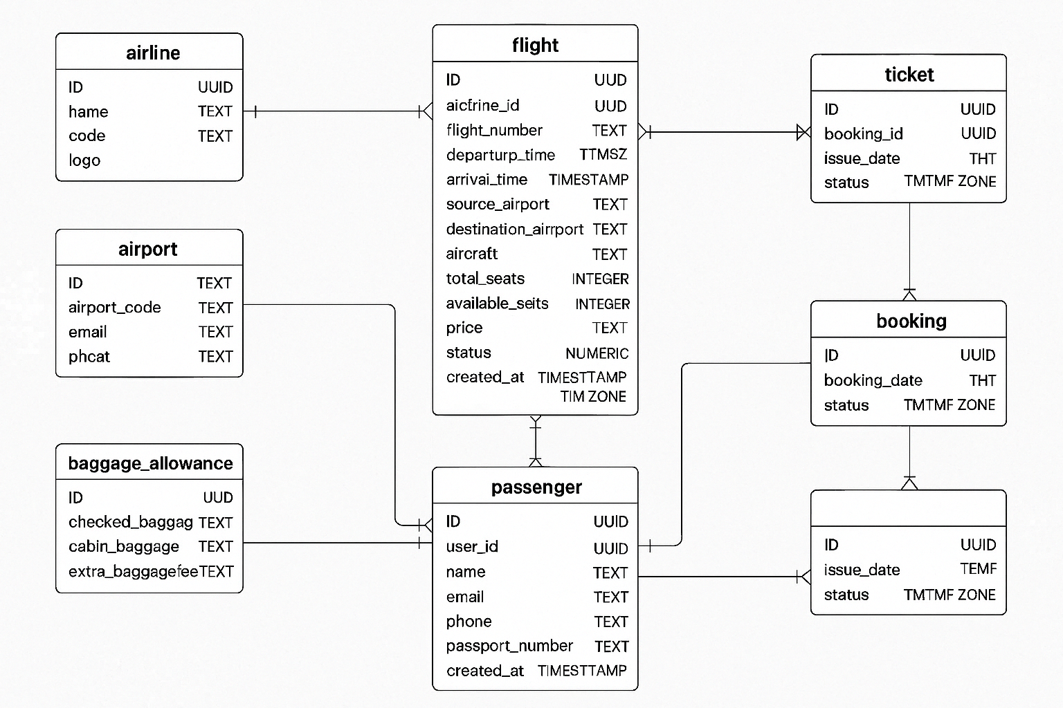

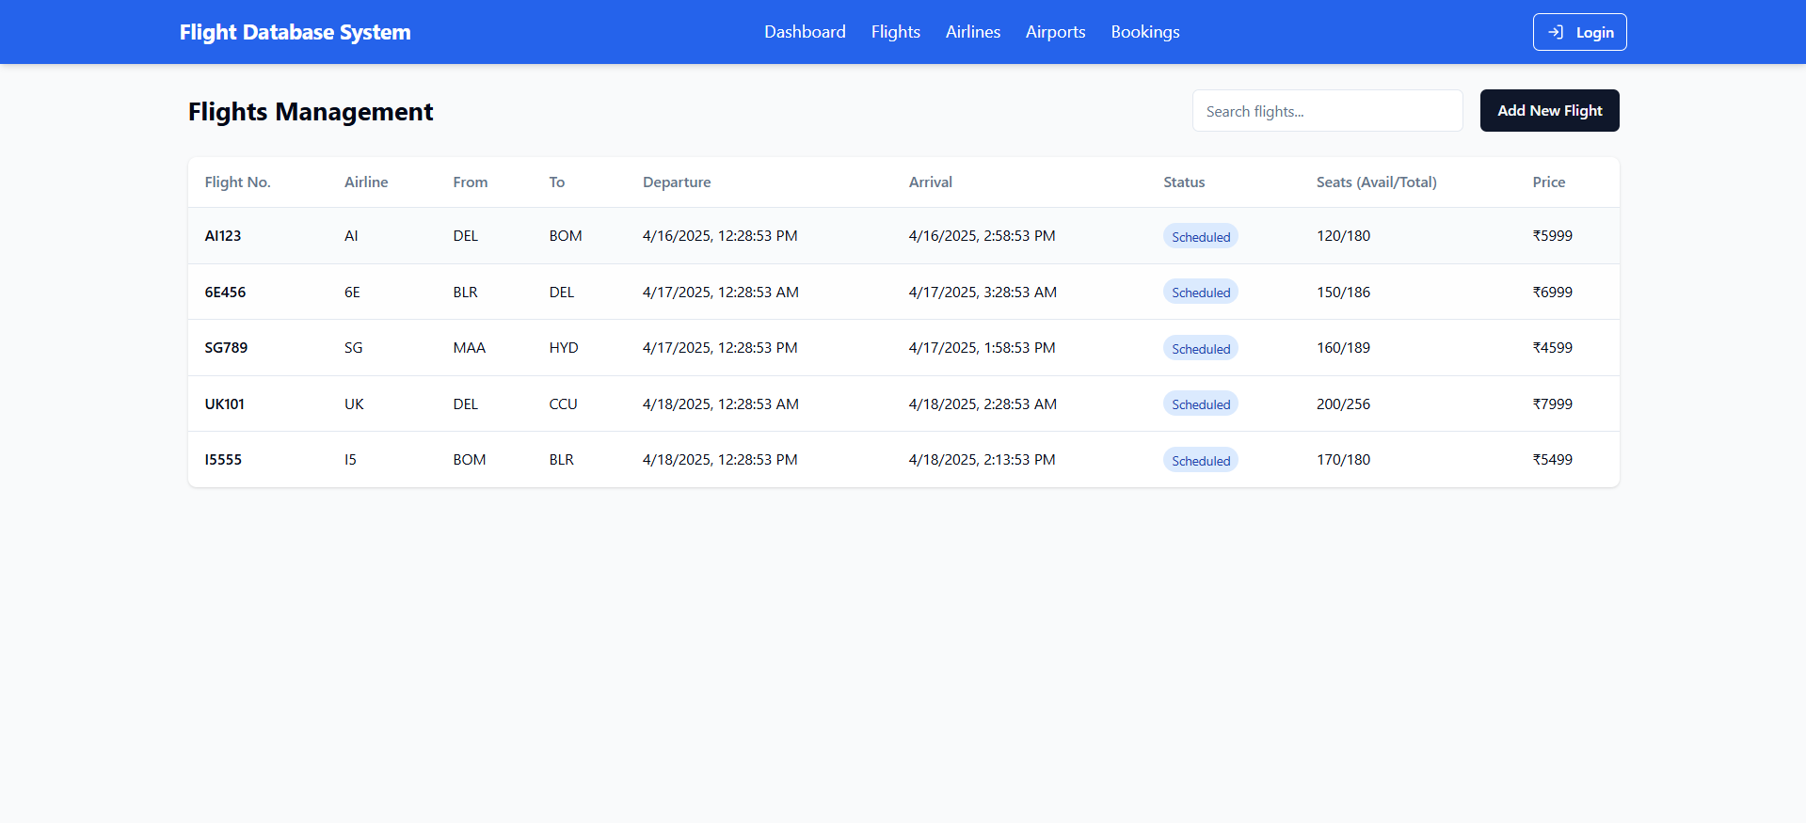
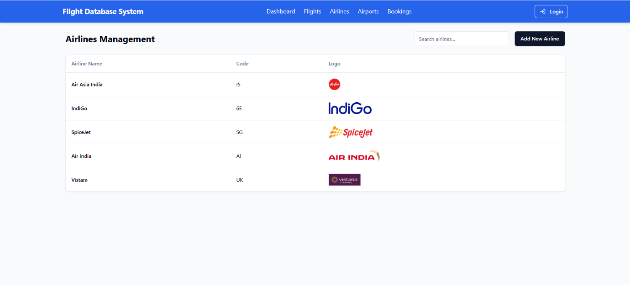
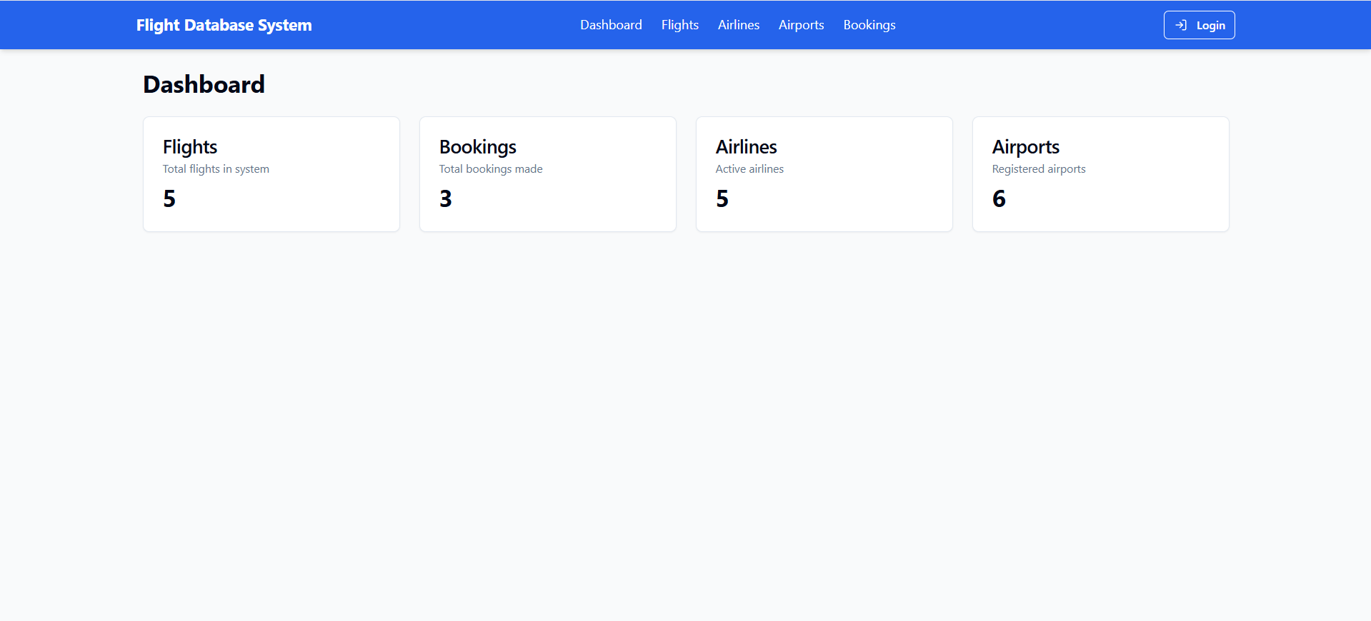
Project UI (Screenshots)

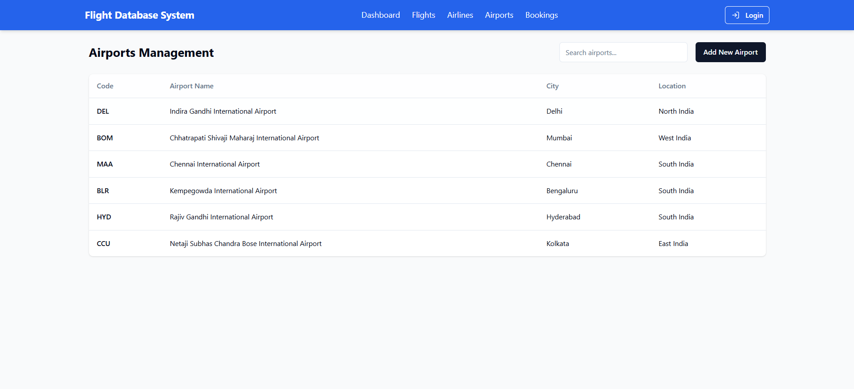
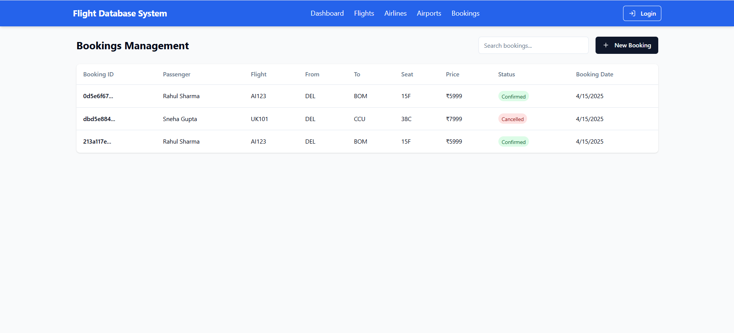
Some complex queries
- List all flights with airline name, departure, and arrival details:
SELECT f.flight_number, a.name AS airline_name,
f.departure_time, f.arrival_time,
src.name AS source_airport, dest.name AS destination_airport
FROM flight f
JOIN airline a ON f.airline_id = a.id
JOIN airport src ON f.source_airport = src.airport_code
JOIN airport dest ON f.destination_airport = dest.airport_code;
- Find fully booked flights (available_seats = 0):
SELECT flight_number, departure_time, arrival_time
FROM flight
WHERE available_seats = 0;
- Get total revenue generated by each airline (from bookings):
SELECT a.name AS airline_name, SUM(b.total_price) AS total_revenue
FROM booking b
JOIN flight f ON b.flight_id = f.id
JOIN airline a ON f.airline_id = a.id
GROUP BY a.name;
- Find all passengers who have more than 2 bookings:
SELECT p.name, COUNT(b.id) AS total_bookings
FROM passenger p
JOIN booking b ON p.id = b.passenger_id
GROUP BY p.name
HAVING COUNT(b.id) > 2;
- List upcoming flights within the next 3 days:
SELECT flight_number, departure_time
FROM flight
WHERE departure_time BETWEEN now() AND now() + interval '3 days';
- Get top 5 most frequently booked flights:
SELECT f.flight_number, COUNT(b.id) AS total_bookings
FROM booking b
JOIN flight f ON b.flight_id = f.id
GROUP BY f.flight_number
ORDER BY total_bookings DESC
LIMIT 5;
- Find passengers who haven’t booked any flight:
SELECT name FROM passenger
WHERE id NOT IN (SELECT passenger_id FROM booking);
- List airlines with their total number of flights:
SELECT a.name, COUNT(f.id) AS total_flights
FROM airline a
LEFT JOIN flight f ON a.id = f.airline_id
GROUP BY a.name;
- Flights with highest price per seat (price/total_seats):
SELECT flight_number, (price / total_seats) AS price_per_seat
FROM flight
ORDER BY price_per_seat DESC
LIMIT 5;
- Average booking price per airline:
SELECT a.name AS airline_name, AVG(b.total_price) AS avg_booking_price
FROM booking b
JOIN flight f ON b.flight_id = f.id
JOIN airline a ON f.airline_id = a.id
GROUP BY a.name;

Tech Stack Used
- Vite: Fast build tool and dev server for modern web apps.
- TypeScript: Adds static typing to JavaScript for safer, scalable code.
- React: JavaScript library for building dynamic, component-based UIs.
- shadcn/ui: Prebuilt, accessible UI components styled with Tailwind CSS.
- Tailwind CSS: Utility-first CSS framework for fast and responsive UI design.

